To create a EFK stack using Docker-compose and see logs on Kibana

Directory structure
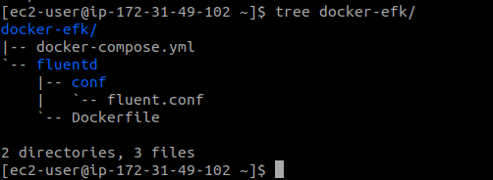

Docker-compose.yml
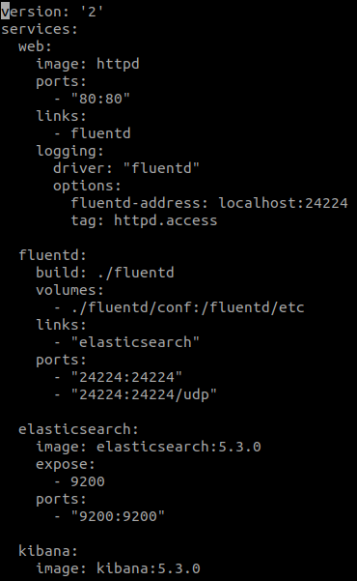
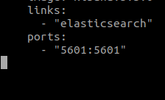

fluentd/Dockerfile

fluentd/conf/fluentd.conf
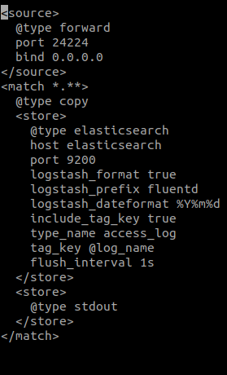

Docker-compose up -d

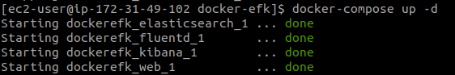

Kibana Dashboard
